Dashboard Design

Date | 27 October 2026
Team ID | Not provided by user
Project Name | Global Olympic Sports Performance Analysis
Maximum Marks | 5 Marks

Activity 1: Interactive and visually appealing dashboards
Creating an effective Streamlit dashboard involves presenting business data stored in Snowflake through clear, interactive, and easy-to-understand visualizations. Students should design the dashboard so that users can quickly understand important KPIs, trends, comparisons, and business insights.
- Clear and Intuitive Layout
- Use Appropriate Visualizations
- Colour and Theming
- Interactive Filters and Slicers
- Drill-Down Capabilities
- Responsive Design
- Custom Visuals and Icons
- Use of Infographics

Note: Highlight the major outcomes in form of bullet points

Olympic Dashboard Design Specification
This template originally demonstrates a Streamlit/Snowflake dashboard. The supplied deliverable implements the visual layer in Tableau; the following content maps the same analytical views to a future Snowflake-backed Streamlit interface. The Streamlit/Snowflake application itself is not included or claimed as implemented.

Clear and Intuitive Layout
Use two sections: overall performance (country rank, category averages, year trend) and regional efficiency (investment, efficiency, host comparisons, region distribution).

Appropriate Visualizations
Use ranked bars for countries/categories, a line chart for years, a scatter plot for investment/medals, a sorted bar for regional efficiency, and a donut/treemap for regional share.

Colour and Theming
Use a neutral background with a consistent blue/teal accent; use color sparingly to distinguish regions and avoid encoding more than one meaning with the same color.

Interactive Filters and Slicers
Suggested filters: year range, country, region and host-advantage label. Apply filters consistently and show selected state.

Drill-Down Capabilities
Allow country selection to reveal rank, total medals and region; allow region selection to reveal the countries represented.

Responsive Design
Use one/two-column layouts; preserve labels and tooltips on laptop and classroom display sizes.

Custom Visuals and Icons
Use minimal sport/medal icons only as navigational aids; keep chart data and labels primary.

Infographics
Use KPI callouts for confirmed totals only; do not display invented numbers or infer causality from association.

Major Analytical Outcomes Supported by the Current Tableau Workbook
• Country ranking and total medal comparison can be explored in the “Global Performance by Country” worksheet.
• Medal movement across Olympic years can be explored in the “Trend of Total Medals Awarded” worksheet.
• Sport-category averages can be compared using “Avg Medals per Athlete by Category”.
• Regional context is covered by “Avg Medal Efficiency by Region” and “Medal Distribution by Region”.
• Investment score versus medal output and host-nation comparison are descriptive context views, not causal evidence.
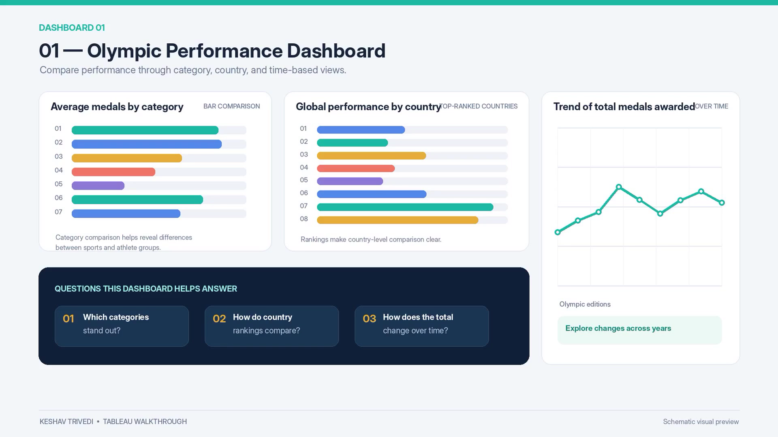
Reference image: Olympic Performance Dashboard from the provided walkthrough.
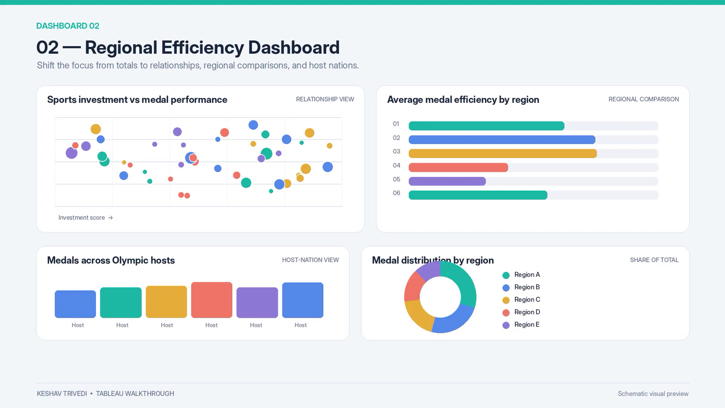
Reference image: Regional Efficiency Dashboard from the provided walkthrough.

Publication / Implementation Status
Current implemented interface: Tableau workbook (.twbx). Snowflake + Streamlit interface: future extension. Tableau Public URL and Snowflake credentials/query logs were not provided; no credentials should be placed in this document.

